**Simple Keras Observations for prac 1**

1.CIFAR 10

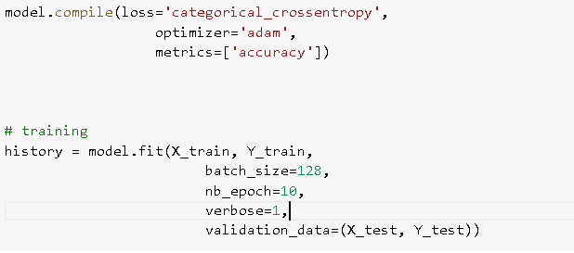

* Changing the epochs from 10 to 15

Epoch 10/20

50000/50000 [==============================] - 39s 782us/step - loss: 1.2903 - acc: 0.5382 - val_loss: 1.3977 - val_acc: 0.5018

Epoch 15/20

50000/50000 [==============================] - 40s 797us/step - loss: 1.1325 - acc: 0.5944 - val_loss: 1.3780 - val_acc: 0.5223

* Changing the epochs from 10 to 20

Epoch 20/20

50000/50000 [==============================] - 39s 781us/step - loss: 0.9520 - acc: 0.6569 - val_loss: 1.4917 - val_acc: 0.5098

* Changing batch size from 128 to 64

Epoch 10/10

50000/50000 [==============================] - 64s 1ms/step - loss: 1.3053 - acc: 0.5292 - val_loss: 1.4199 - val_acc: 0.5028

* Changing batch size from 128 to 256

Epoch 10/10

50000/50000 [==============================] - 28s 558us/step - loss: 1.2991 - acc: 0.5373 - val_loss: 1.4318 - val_acc: 0.4937

* Changing optimizer from adam to rmsprop

Epoch 10/10

50000/50000 [==============================] - 36s 711us/step - loss: 1.4248 - acc: 0.4929 - val_loss: 1.4737 - val_acc: 0.4861

2.IRIS

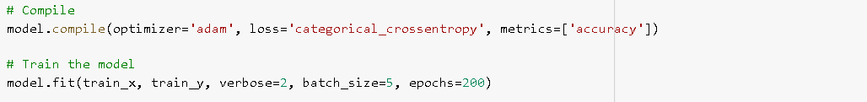

* Changing the epochs from 200 to 100

Epoch 100/200

- 0s - loss: 0.0791 - acc: 0.9865

Epoch 200/200

- 0s - loss: 0.0566 - acc: 0.9865

* Changing the epochs from 200 to 300

Epoch 300/300

- 0s - loss: 0.0583 - acc: 0.9797

* Changing batch size from 5 to 10

Epoch 200/200

- 0s - loss: 0.0655 - acc: 0.9730

* Changing optimizer from adam to rmsprop

Epoch 200/200

- 0s - loss: 0.0658 - acc: 0.9797

2/2 [==============================] - 0s 123ms/step

Final test set loss: 0.036648

Final test set accuracy: 1.000000